Our ref: IRF24/2162

Ms Gail Connolly

Chief Executive Officer

City of Parramatta Council

PO Box 32

PARRAMATTA NSW 2124

Dear Ms Connolly

**Planning proposal** PP-2024-1406 **to amend the** Parramatta **Local Environmental Plan** 2023

I am writing in response to the planning proposal you have forwarded to the Minister under section 3.34(1) of the Environmental Planning and Assessment Act 1979 (EP&A Act) which seeks to amend planning controls relating to the Parramatta CBD.

As delegate of the Minister for Planning and Public Spaces, I have determined that the planning proposal should proceed subject to the conditions in the enclosed gateway determination.

I have also agreed, as delegate of the Secretary, the inconsistency of the planning proposal with applicable directions of the Minister under section 9.1 of the EP&A Act, Direction 4.1 Flooding, 4.5 Acid Sulfate Soils, 6.1 Residential Zones are justified in accordance with the terms of the Direction.

The proposed local environmental plan (LEP) is to be finalised on or before 30 July 2025. Council should aim to commence the exhibition of the planning proposal as soon as possible. Should Council seek to make a proposed LEP, the request to draft the proposed LEP should be made directly to Parliamentary Counsel’s Office well in advance of the date the proposed LEP is projected to be made. A copy of the request should be forwarded to the Department of Planning, Housing and Infrastructure.

Should you have any enquiries about this matter, I have arranged for Peter Pham to assist you. Mr Pham can be contacted on 9860 1593.

Yours sincerely

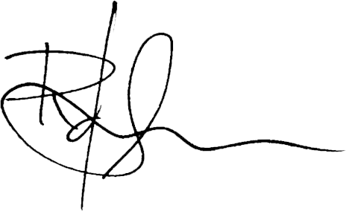

**Rukshan de Silva**

**Director, Local Planning and Council Support**

**Planning, Land Use Strategy, Housing, and Infrastructure**

Encl: Gateway determination